**Phase 1 - Course-end Project 1**

**Lockers Pvt. Ltd.--LockedMe.com Project**

**Developed by:** Narendra Kumar .V

(Emp-ID_10847)

**Project objective:**

As a Full Stack Developer, complete the features of the application by planning the development in terms of sprints and then push the source code to the GitHub repository. As this is a prototyped application, the user interaction will be via a command line.

**Project Overview:**

This project is designed to perform operations on file names stored in a list or array basically this project will perform operations like retrieving elements in ascending order, adding a file in to the list , Deleting a file from the list or searching a file if it exists in the list or not we will build a command line project with basic UI which will display at first the main menu which have options of retrieving array in ascending order the second option is to redirect the curser to perform Various file operations like adding , deleting and searching in the list of files.

**Sprint Planning:**

I have Dividing the project into 2 sprints

--Before the first sprint I have listed out the features and operations to be performed in the project and noted down

--In the first Sprint I have coded a basic template for the project which will display the Main Menu and Operation we could perform using switch concept in java I made sure that every option which user enter are working if the option is invalid then user will get a Invalid input Message it took me around 3-5 days to complete this

--After the ­First Sprint I have decided to Select a data structure Array list because it can store dynamic data we don’t know how much data will user enter or how many time that is why I have decided to go with Array list

--In the Second Sprint I have started the implementation of Array list operations like adding the element in the list ,Deleting it, Searching for a particular element , and for retrieving the elements in ascending order I have used Collections.sort() method as it will automatically sort the elements in the Array list , I have added the Try and catch block for some code as they may throw Exceptions After the completion of the project I have done testing with several test cases.Second sprint took around 4-6 days to complete

**Flow Chart of the Project**

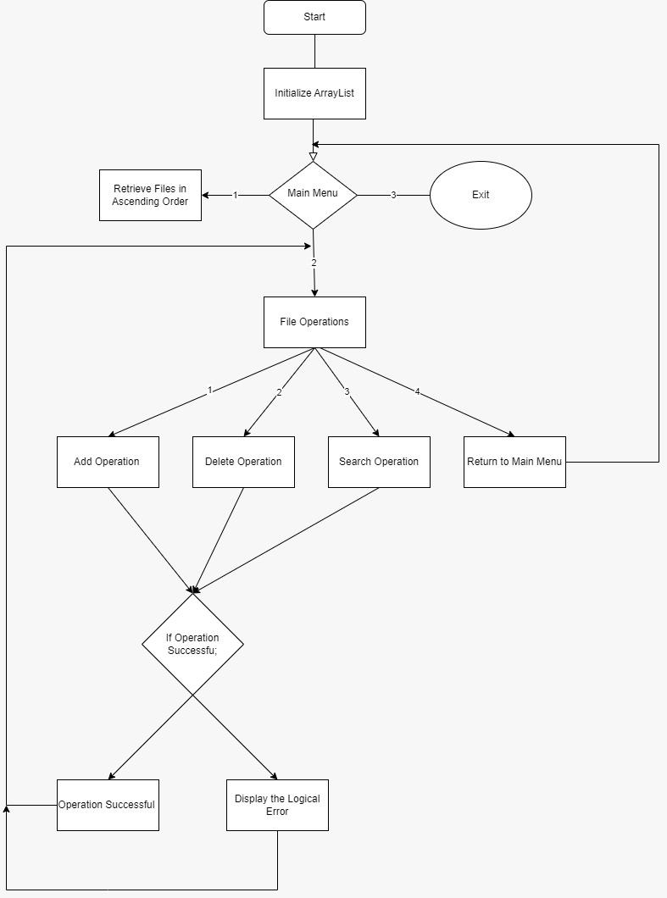

**Java Concepts Used:**

Array list

Try and catch block

Switch statement

Break statement

While Loop

Scanner Class

**Project Git hub link:**

[Java-Training/Phase_1_Project.java at main · Naren-18/Java-Training (github.com)](https://github.com/Naren-18/Java-Training/blob/main/Core_Java_Training/src/Project/Phase_1_Project.java)

**Conclusion and Unique Selling Points:**

This is a Basic Prototype project for lockedme.com which performs list operations like adding , deleting and searching , it is a command line project

Further we can Design a UI for this project and implement database to store data